**MacroHard Inc. Presents:**

**Solar Strife**

**Members:**

* Evan Apostolou
* Jacob Shultz
* Ademola Adesoji
* Andrew Choi
* Chase McIntosh
* Edwin Sanchez

**Index:**

Rules ----------------------------------------------------------------------------------------- Pgs. 2-4

Story ----------------------------------------------------------------------------------------- Pg. 5

Art ------------------------------------------------------------------------------------------- Pgs. 6-10

**Rules:**

* Place down the board, both players will have SIXTEEN (16) playing pieces and will have each piece placed on the designated territory (marked in a BLUE or RED zone on the board). Have the player place their **monitor** class ships on the corners of the player’s territory on the first row, next the player should place their **destroyer** class ships next to their **monitor** class ships, as well as their **cruiser** class ships. The **dreadnought** class ship should be placed on the home planet, and the **carrier** class ship should be placed in the last spot of the first row. Then the player should place all **scout** class ships at the second row of their territory. Finally, have each player roll the THREE (dice) and whoever has the higher number goes first, if you much rather want to start quickly, then BLUE goes first.
* During a player's turn, the player will move one of their ships towards their opponent’s side of the board. All ships can move freely albeit in a straight line, for example, A ship that can move TWO (2) spaces diagonally, and a ship that can move THREE (3) spaces back as long as it is a straight line. A ship that can move THREE (3) spaces cannot move ONE (1) space forward and TWO (2) spaces right, as that is not considered a straight line.
* When a ship is in the range of an enemy ship, the ship can begin to fire. A ship’s firing distance is determined by the THREE (3) numbered dice, however if a ship fires at point blank no dice are needed.
* When a ship shoots at an enemy ship that is within firing range, has a clear shot, and has rolled a successful number to actually hit the enemy ship, the enemy ship will get hit and either lose one shield or will get destroyed, if a ship
* If the opponent’s ship is within your ship’s movement range your ship can ram the opponent’s ship.
* Ramming will damage both ships relative to the number of shields your ship has, for example, a **scout** class ship ramming against a **cruiser** class ship with ZERO (0) shield will destroy both ships. However a **scout** class ship ramming against a **cruiser** class ship with ONE (1) shield will destroy the **scout** and leave the **cruiser** class ship with ZERO (0). To go further, A **destroyer** class ship ramming with THREE (3) shields ramming a **carrier** class ship with TWO (2) shields will destroy the carrier class ship and leave the **destroyer** class ship with ONE (1) shield. If ramming destroys the enemy ship, the player’s ships will be where the enemy’s ship was.
* **scout** and **carrier** class ships can move THREE (3) spaces on the board; **monitor**, **cruiser**, and **destroyer** class ships can move TWO (2) spaces; **dreadnought** class ships can only move ONE (1) space.
* The **scout** class ship’s firing range is ONE (1) through SIX (6), so the player will only have to roll ONE (1) D6 die. The **monitor**, and **cruiser** class ship’s firing range is TWO (2) through NINE (9), so the player will roll ONE (1) D6 die and ONE (1) D3 die. The **dreadnought** and **destroyer** class ship’s firing range is ONE (1) to THREE (3), so the player will only have to roll ONE (1) D3 die. A **carrier** class ship’s firing range is TWO (2) through TWELVE (12), so the player will have to roll TWO (2) D6 dice.
* **scout** class ships can only shoot straight, **monitor** class ships can shoot in cardinals, **destroyer** class ships can shoot in a radius, **cruiser** class ships can shoot in diagonals, and both **carrier** and **dreadnought** class ships can shoot in all EIGHT (8) directions.
* **scout** class ships do not have shields, so they can only be hit once; **monitor**, **cruiser** and **carrier** class ships hold ONE (1) shield, so they can be hit twice; **destroyer** class ships can hold TWO (2) shields, so they can be hit three times; **dreadnought** class ships can hold THREE (3) shields and can be hit four times.
* While playing, the player may encounter PLANET, PLANETS are integral to winning, as the player with the most PLANET captured after the turn limit will win.
* When a PLANET is captured, the player can teleport any ship on top of said PLANET, so long as neither yours nor the opponent’s ship is on top of it.
* While playing, the player may encounter ASTEROIDS, ships may NOT move over ASTEROIDS. Certain ships can shoot over ASTEROIDS.
* After both players have finished their turns, the 2nd player will draw a turn card. When all turn cards have been drawn the game will end.
* The player can either win by capturing their opponent's home PLANET, wiping out their opponent’s fleet, or having the most PLANETS captured at the end of the game.

**Story:**

Solar Strife takes place in the same universe as Cavern Clash. The Voldkrigs, a militarist Dwarf empire, have begun a war with the United Orc Clans. The Scrack system was designated as a DMZ, (demilitarized zone) after a temporary peace was brokered between the two sides, as both factions, along with many others, were forced to withdraw troops and ships to repel the third Synth Uprising. The Voldkrig world of Vakt sits on one end of the system, with the Orc world of Borta sitting on the other. Between the two sit several uninhabited planets. One Ecumenopolis of unknown origin, three planets that could potentially be used as Agriculture worlds. Two worlds believed to be numerous in minerals and resources. And, finally, a dead world, completely devoid of life. Voldkrig high command believes that a world-ending weapon could be on the planet, and thus have ordered it taken. Each side is also careful not to leave their “home” planets open to attack, their home planets contain their fleet command for the Scrack system, and if it is destroyed, their fleet will be forced to pull out of the system. The Voldkrig and Orc fleets have stationed themselves at their respective planets and now are poised to begin their war for the Scrack System. Each fleet is roughly the same size composed of similar classes of ships, scouts, cruisers, destroyers and monitors comprise a majority of the fleets. However each fleet also has a carrier and a dreadnought within them. These are high value targets for each side, as they are the core of their respective fleets, and their destruction would be a major blow for the morale of the fleet.

**Art:**

The art for this game consists mainly of physical pieces, such as the board, the player’s pieces, the equipable Shields, and the Turn Cards. In the works are 3D models for the player pieces to be exchanged with in our next iteration.

Board:

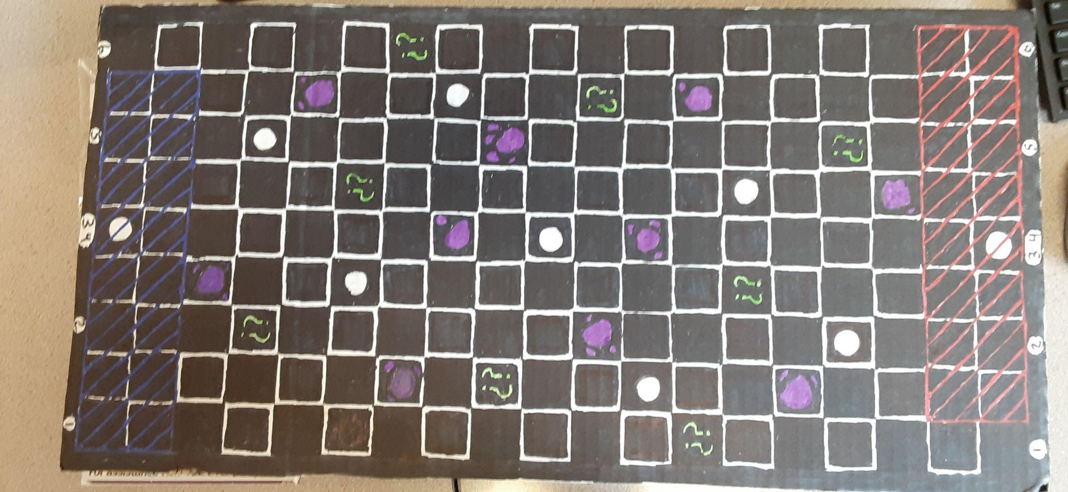

Player Pieces:

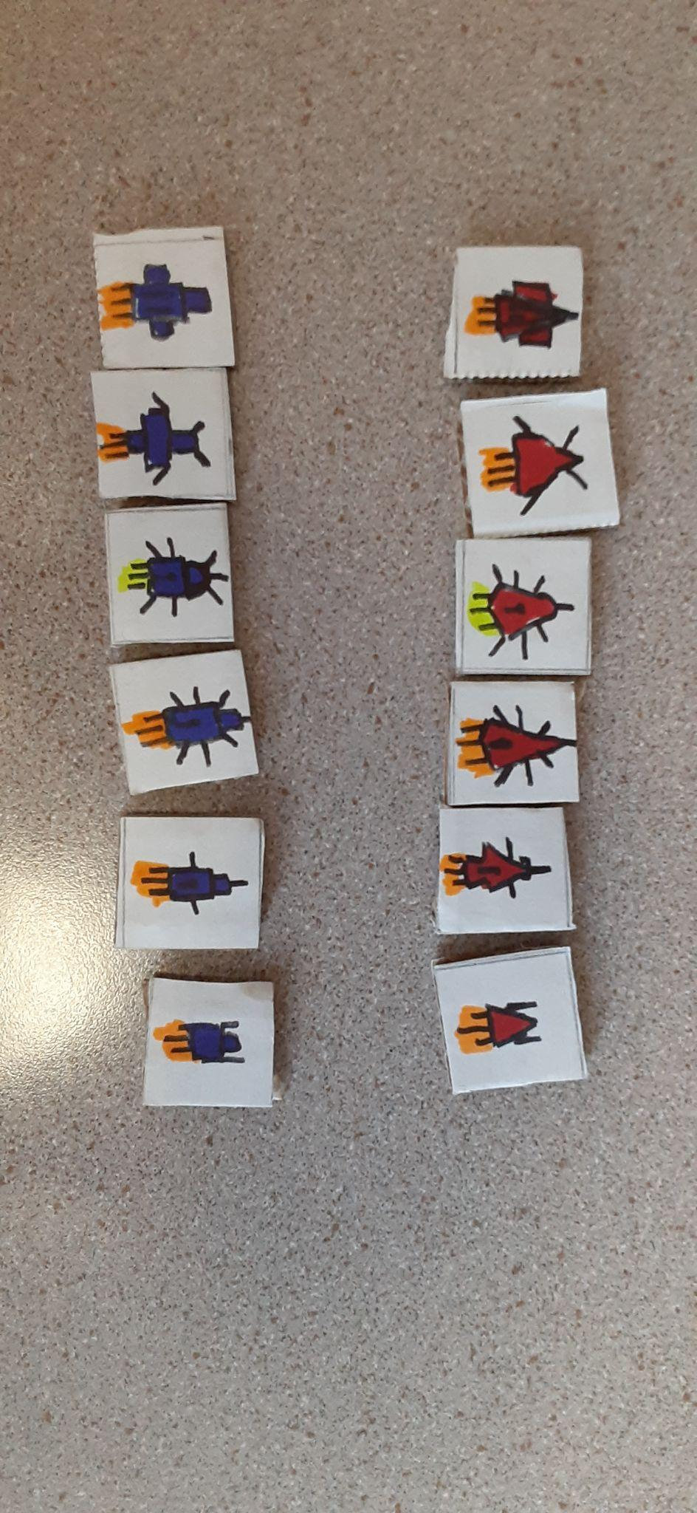

Shields:

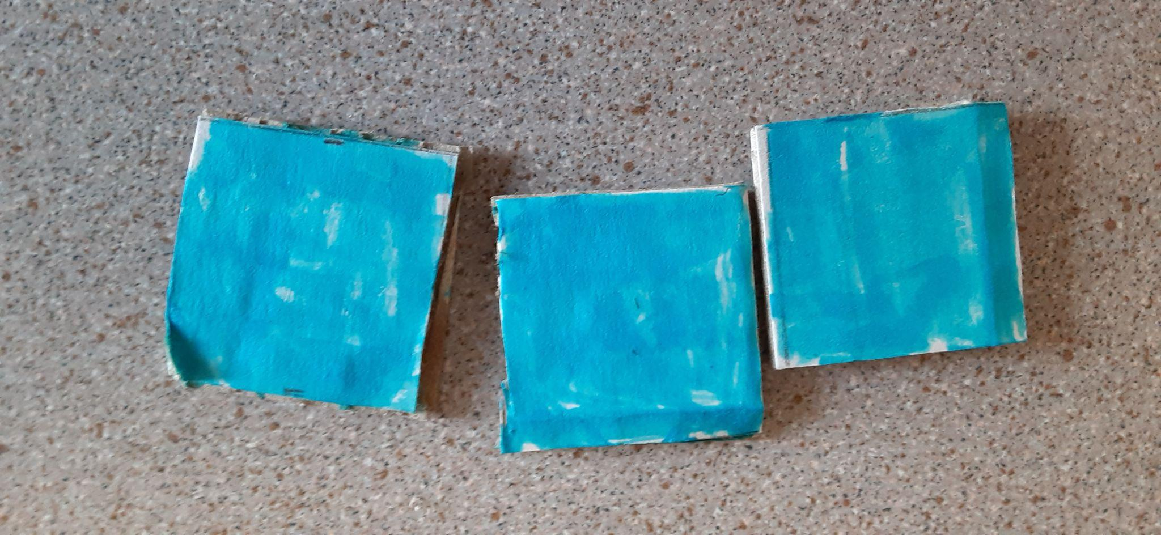

Turn Cards:

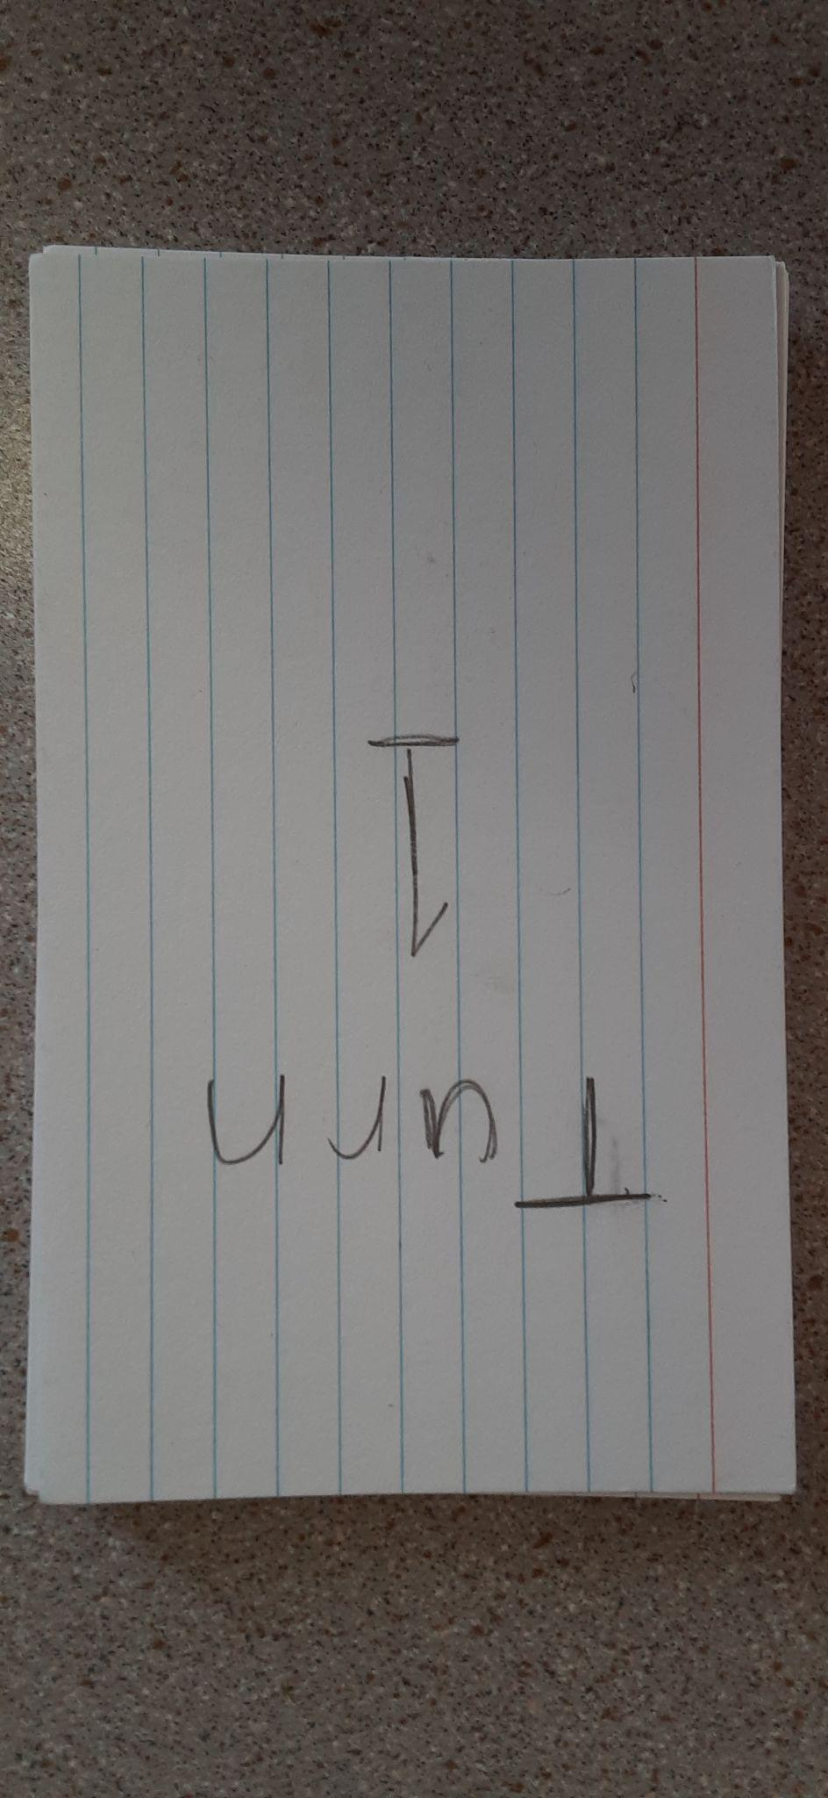

Cruiser:

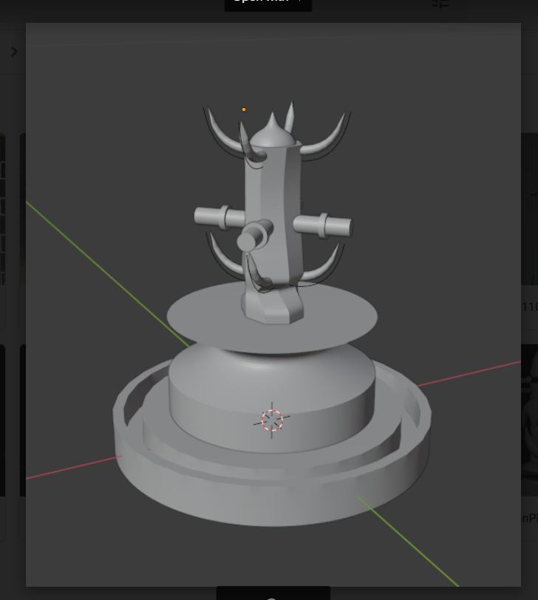

Dreadnought:

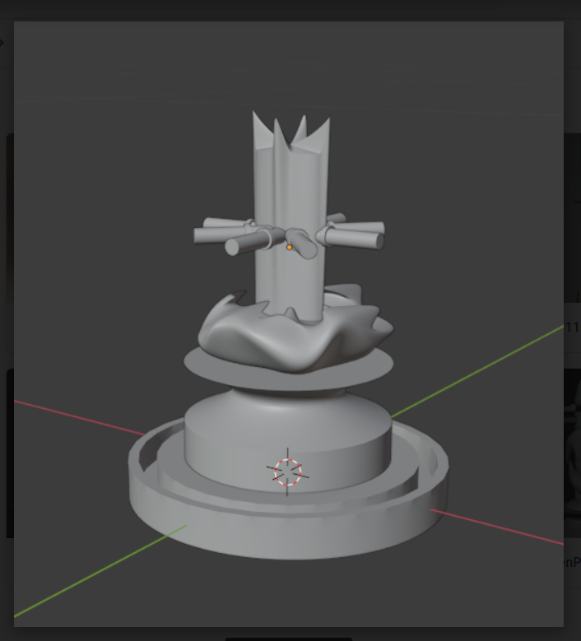

Destroyer:

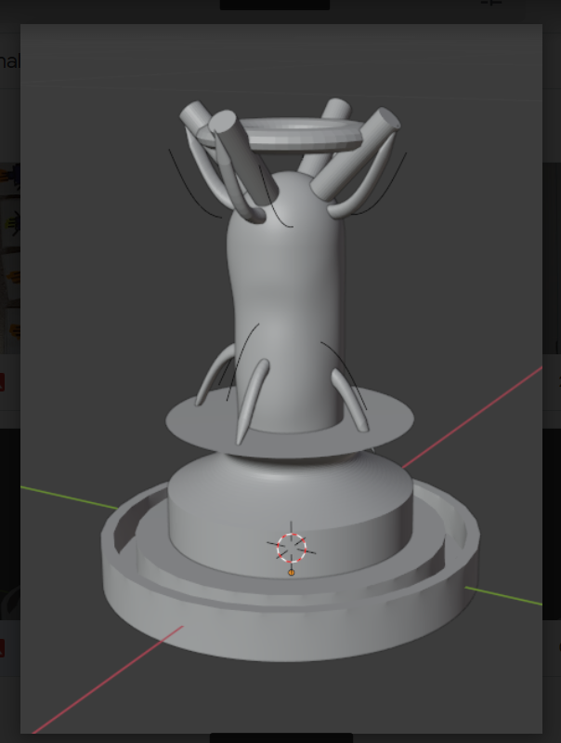

Scout:

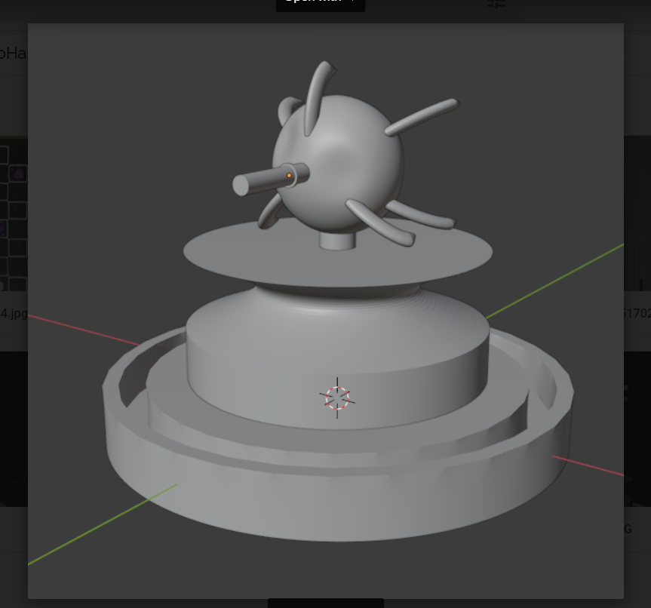

Carrier:

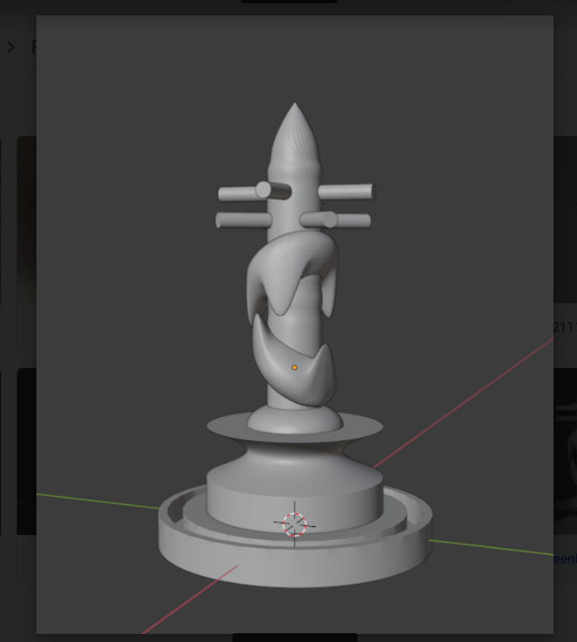

Monitor:

